

Parish Safeguarding Officer Induction

Participant Handbook

  - Version 2 January 2025

Table of Contents
1. Welcome and Introduction 3
2. Aim and outcome of this training pathway 3
Structure of this course 4
4. Preparatory tasks for your PSO Induction session 4
5. The PSO induction training 6
The Role and tasks of the Parish Safeguarding Officer (PSO) 6
Model Parish Safeguarding Checklist 8
Safeguarding scenarios 11
Dynamics of which to be aware 11
Safeguarding case management groups 12
What to do when a concern is aised 13
Recording the Four Ws 14
Use of social media 15
6. Parish Safeguarding Officer (PSO) Safeguarding Development Plan 16

1. Welcome and Introduction

Thank you for agreeing to be a Parish Safeguarding Officer. Yours is an important role in the creating and maintaining of a healthy safeguarding environment in our parish churches and settings.

Introduction
The national safeguarding training and development practice guidance sets out the framework for safeguarding training to ensure that all Church officers are trained in aspects of safeguarding:.
- They must develop and maintain the necessary knowledge, attitude, and skills to safeguard and protect children, young people, and vulnerable adults.
- It is essential that churches understand safeguarding as a theological imperative, rooted in the nature and love of God, and outworking in basic commitments to giving equal worth to all.
- Parish life is the heart of the Diocese and is the most important context to get our safeguarding right. The Parish Safeguarding Officer role is a vital one – the ‘champion’ of safeguarding in the parish.

2. Aim and outcome of this training pathway
Aim
To equip you with an understanding of the role of the Parish Safeguarding Officer and induct you into key working practices and relationships

Learning Outcomes
By the end of this pathway participants will be able to:
- Understand the role, responsibilities, and key working relationships of the Parish Safeguarding Officer, including the Local Authority, Diocesan Safeguarding Officer (DSO) and Parochial Church Council (PCC).
- Identify a variety of approaches to raising awareness and improving safeguarding practice.
- Evaluate safeguarding information reported by members of the church or community and determining an appropriate response.
- Create a development plan for safeguarding practice in their context.

Structure of this course
- This is an induction session. The purpose of an induction session is to introduce people to the PSO role making sure that they have all the tools required to carry out the job successfully.

- A PSO will have completed the Basic, Foundation and Leadership safeguarding learning pathways before or soon after attending this induction session.

- Other training will become available from time to time and your diocesan team will advise you of any updates to training or resources as they occur.

- The focus of the session is to equip participants with an understanding of the role of the Parish Safeguarding Officer and induct them into key working practices and relationships. Following this you will be able to develop your own development plan to support you in this role.

4. Preparatory tasks for your PSO Induction session

Your induction session will be a facilitated dialogue about the PSO role and its requirements.

In order that you get the most from the session, it is important that you have read sections 1-4 of this Handbook and completed the preparatory tasks as listed below. This will be key for you to be able to fully benefit from the session and to ask any questions or concerns you may have about the role during the session.

You are asked to complete the following tasks before attending your induction session:
NB: The Policies and Procedures referred to in this Handbook are under review in 2025. Your Diocesan Safeguarding team will keep you updated about revisions and changes.

1. Pre-reading: Policy and practice guidance | The Church of England
- PSO Information and Welcome Pack
Information & Welcome Pack Dec 24.pdf

Parish Safeguarding Handbook - being updated in 2025 and will become a digital resource
https://www.churchofengland.org/sites/default/files/2019-10/ParishSafeGuardingHandBookAugust2019Web.pdf

PSO Check list - Included at the end of this booklet

Safer environments

safer-environment-and-activities-oct19_0.pdf (churchofengland.org)

Code of Safer Working Practice Policy and Safer Practice Guidance – Church of England
code-of-safer-working-practice-02.07.2021.pdf (churchofengland.org)

2. Reflection task

Think about your journey to becoming a Parish Safeguarding Officer; What previous safeguarding experience do you have? How did you come to the role? What is your motivation for undertaking the role? What personal qualities do you bring? What ambitions do you have for the role going forward?

3. Case study

Please read the case study below in preparation for discussion during the session:
Case study
You have recently attended a PCC meeting to give a safeguarding update on the agenda and learned that several the PCC are very unhappy about the fact that they need to undertake safeguarding training. They say that it is ridiculous and that they simply will not do it. One lady (who is considered a stalwart of the church and commands a lot of respect) has just said “if she has to do any form of safeguarding training then she will simply leave her role and the church will die without volunteers“. The lady goes on to say to the other members of the PCC “I have been at this church for over 20 years and there have never been any safeguarding things happen !! And what is more, there are unlikely to be any safeguarding things happen because the only time we get children is Easter and Christmas”.
How would you respond to these concerns raised by some PCC members and how would you address this?
4. Your questions
Please make a note of any specific questions you have that you will be hoping to find answer for in the session. At the end of the session, if they have not been answered there will be plenty of time to ask questions.

5. The PSO induction training
Safeguarding in the Church of England
The Church is committed to the flourishing of all individuals, and therefore works to create a healthy environment across all its settings. It is important to see Safeguarding in its theological context and not just as a box to be ticked. This quotation from the PSO Welcome Pack sets it out like this:
“The work of overseeing safeguarding is one of the most supportive and important tasks undertaken by the Parochial Church Council (PCC). In this work we demonstrate safe caring for one another, and our commitment to the flourishing of all in a tangible way.”

What is Safeguarding?
It is important to arrive at a shared understanding of what we mean by Safeguarding. As a group you will consider the following:
Is safeguarding:
- something that is a bureaucratic exercise?
- a theological imperative about how we keep people safe in church?
- separate from the church?
- a box to tick or something that must be at the centre of our mission and ministry?

The Role and tasks of the Parish Safeguarding Officer (PSO)
The role
The role and task of the PSO may vary across settings depending on the differing roles engaged to assist with safeguarding. Broadly the role can be outline as follows:
- The Parish Safeguarding Officer is the key link between the diocese and the parishes, concerning safeguarding matters
- S/he will have an overview of all church activities involving children, young people and vulnerable adults and will seek to ensure the implementation of safeguarding policy
- The role can be taken by one person or the role shared, for example with one person covering children the other vulnerable adults

- The Parish Safeguarding Officer is a key leadership position in relation to safeguarding – but they are not solely responsible for safeguarding in their parish: responsibility lies with the PCC and the PSO is their delegated lead. To this end their role is about positively shaping the culture of safeguarding in the parish together with other leaders

The tasks
Training
- Attend diocesan safeguarding training offered for PSOs (Core training/PSO induction/DBS/Dashboard as relevant
- Advise church officers of their training requirements and direct (if needed) on how to register for training
- Be prepared to undertake training and relate to DBS, training and Dashboard and Hubs and monitor and oversee these tasks
- Have a knowledge of safeguarding policies and know how to source them
Disclosure and Barring Service (DBS)
- Ensure that the Church officers have role relevant DBS
Activities in the Parish
- Ensure the PCC adopt the National Safeguarding Policy
- Ensure that the Church Safeguarding Policy and contact details are displayed in all Church premises.
- Ensure that the Safeguarding Dashboard is kept up to date
- Safeguarding must be a standing item on all PCC Agendas
- Have an overview of church activities involving children and vulnerable adults and ensure relevant records are kept of such events.
- Ensure that leaders of activities are fully aware of and are implementing relevant guidance.
- Keep in touch with the leaders of all activities and offer them advice and support over safeguarding matters
- Where events are taking place off-site, liaise with Wardens to ensure an appropriate risk assessment has been prepared using both Safeguarding and Health and Safety lenses
- Ensure external activity providers provide evidence of their safeguarding policies/risk management or adopt the Parishes
Reporting/Recording
- Keep the church leadership informed of good safeguarding practice
- Undertake a regular parish safeguarding self-assessment in the format offered by the Diocese
- Liaise with the discloser of concern as appropriate, offering support as needed
- Assist with safeguarding training in the parish as appropriate
- Send a Dashboard report on current safeguarding to the PCC meeting (and/or)
- Attend PCC meeting to ensure safeguarding issues are discussed. Keep good records of any safeguarding concerns that may arise, and ensure that others do the same
- Promote inclusiveness in places of worship and within church activities
- Liaise with the incumbent over safeguarding issues
- Liaise as necessary with the Diocesan Safeguarding Advisers
- Report all concerns or allegations to the Diocesan Safeguarding Team

The Parish Dashboard

A video has been produces to introduce PSOs to the Parish Dashboard and you might find this useful. It lasts 12 minutes and can be viewed as 6 x 2 minute sections: you may wish to share it with your PCC.

You will find it here:
https://safeguardingtraining.cofeportal.org/mod/page/view.php?id=2782

Policies and Procedures

In readiness for this session we asked you to view a series of useful documents. They include policies and procedures that explain our safeguarding arrangements across the Church. The slide below show a pictural image of some of them and you can review the links to them on page 4 and 5 of this Handbook. You can find the documents here: Policy and practice guidance | The Church of England
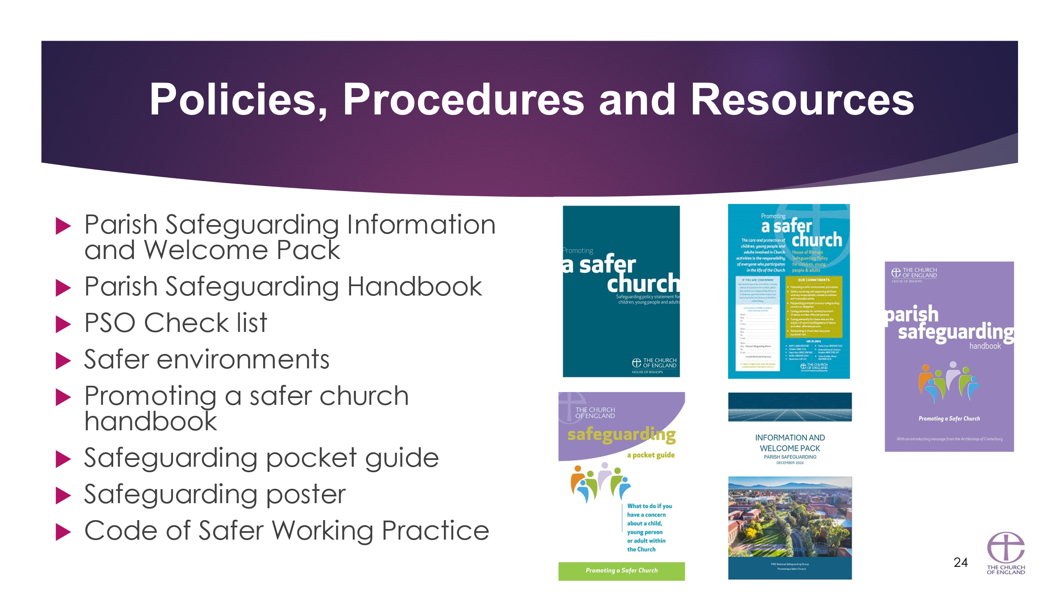

PSO Information and Welcome Pack
Information & Welcome Pack Dec 24.pdf

Parish Safeguarding Handbook - being updated in 2025 and will become a digital resource
https://www.churchofengland.org/sites/default/files/2019-10/ParishSafeGuardingHandBookAugust2019Web.pdf

PSO Check list - Included at the end of this booklet

Safer environments

safer-environment-and-activities-oct19_0.pdf (churchofengland.org)

Promoting A Safer Church
safer (churchofengland.org)

Safeguarding: A Pocket Guide
https://www.chpublishing.co.uk/books/9780715111499/safeguarding-a-pocket-guide-pack-of-50

Model Parish Safeguarding Checklist
At insert Parish name we recognise that the few who are determined to harm children or adults, deliberately seek out groups or organisations where they can meet children or other vulnerable people. The Church is particularly vulnerable to these people. Creating and maintaining a safeguarding culture will discourage them from becoming involved for the wrong reasons and make it difficult for them to harm or abuse children or adults if they do.
To assist with the creation of a safeguarding culture each PCC (or equivalent charitable body) must:
Appoint:
- At least one appropriately experienced designated Parish Safeguarding Officer (PSO) to work with the incumbent and PCC. This PSO should be a lay person. The PSO may also be the DBS administrator for church officers who work with children or vulnerable adults but if not, the PCC should appoint another individual. The PSO should be supported, trained, and given a copy of the parish safeguarding policy and procedures; (see separate Model PSP role description)
Safer recruit, support and train:
- Ensure that all church officers who work with children, young people and/or vulnerable adults are:
  - recruited following the House of Bishops’ Safer Recruitment practice guidance.
  - aware of and work to House of Bishops’ safeguarding guidance (includes both policies and practice guidance).
  - attend diocesan safeguarding training at least every three years.
- Provide appropriate insurance to cover for all activities undertaken in the name of the PCC which involve children and vulnerable adults.
Display:
- A formal statement of adoption of the House of Bishops ‘Promoting a Safer Church; safeguarding policy statement’. This should be signed on behalf of the PCC.
- Contact details of the PSO, Churchwarden and any other local leaders.
- Contact details for the Diocesan Safeguarding Team – including phone, email, and website details.
- Information about where to get help with child and adult safeguarding issues, domestic abuse, and key helplines e.g., ChildLine (See separate ‘Model Safeguarding in parishes-who’s who’)
- Provide access to a hard copy Parish Safeguarding Handbook (see separate Handbook)
- Provide access to a hard copy of the Diocese Safeguarding Manual

Respond:
- Create an environment, which is welcoming and respectful and enables safeguarding concerns to be raised and responded to openly, promptly, and consistently.
- Have a procedure in place to deal promptly with safeguarding allegations or suspicions of abuse in accordance with the relevant policy and practice guidance and in consultation with the Diocesan Safeguarding Adviser.
- Report all safeguarding concerns or allegations against church officers to the Diocesan Safeguarding Adviser.
- To ensure that known offenders or others who may pose a risk to children and/or vulnerable adults are effectively managed and monitored in consultation with the Diocesan Safeguarding Adviser.
- Comply with all data protection legislation especially regarding storing information about the ‘church workforce’, including volunteers and any safeguarding records.
- Ensure that an “activity risk assessment” is completed and reviewed regularly for each activity, which is associated with either children or vulnerable adults, and run in the name of the Church.

Review and report progress:
- The PSO should regularly report on safeguarding in the parish. Safeguarding should be a standing agenda item at each PCC meeting. At the APCM the PCC should provide an annual report in relation to safeguarding. In the PCC’s annual report will be a statement which reports on progress and a statement as to whether or not the PCC has complied with the duty to have “due regard” to the House of Bishops’ guidance in relation to safeguarding.

Other points to consider:
Are you working in an LEP?
- If working within Local Ecumenical Partnerships (LEPs), agree which denomination or organisation’s safeguarding policy to follow, including where to seek advice in urgent situations in line with the practice guidance. This decision should be ratified both by the bishop and other appropriate church leaders in the partnership and shared with the DSA; in the event of a specific safeguarding concern, ensure that all the LEP partners are notified.
Irrespective of this choice all abuse cases arising in Church of England settings must be notified to the Diocesan Safeguarding Team.

Hire out your church premises?
- Any hire agreement with any person/body wishing to hire church premises must contain a provision whereby the person/body hiring the premises agrees to comply with the relevant safeguarding guidance issued by the House of Bishops and the diocese (see separate Model Safeguarding Provision that can be attached to any Hire of Church Premises Agreement).
- The hire agreement should also contain a provision whereby all those hiring church premises are required to ensure that children and vulnerable adults are always protected, relevant staff have had appropriate DBS checks and that all reasonable steps have been taken to prevent injury, illness, loss, or damage occurring.
- Ensure that all those hiring church premises carry full public liability insurance for this or are covered through the church insurance (for example hire for a children’s party).

Do you have a clergy vacancy?
- During an interregnum, the PCC must, working with the churchwardens, ensure that all information about safeguarding matters is securely stored before passing the information on to the new incumbent. The departing incumbent must give the safeguarding information to the Parish Safeguarding Officer who can pass the information on to the new incumbent when he/she takes up his new role.
Support & compliance
The measures identified in the list above will be checked during parish visitations and the documents referred to can be found on National website or Diocesan Website. If you have questions or need support to complete the steps on the checklist you can contact the DSA for further support and advice:
Diocesan safeguarding phone number: ______________

You may need to respond to any of the following:
- Pastoral encounters with members of the congregation or in the community
- Information or observation about a child or adult at risk of harm which needs to be referred to statutory agencies
- Information from the Diocesan Team about those who pose a risk

Safeguarding scenarios
During the session we will discuss the case study you were asked to read before
attending. This session. Please see page 5. Below are the additional scenarios that may be explored during the session.
Additional scenarios
- A child at a church club is frightened to go home because he is afraid his dad will punish him physically for getting a bad test result at school.
- A physically disabled adult is reprimanded, patronised and excluded from some church activities because of her attention-seeking behaviour.

- A man reports that as a child he was told in a confirmation class about hell and this terrified him, because he deduced that all his family would go to hell. His mother had a life-threatening illness at the time.
- Kirsty, a 13 year old girl, attends the church youth club with her friends, who are chatting with each other in the church kitchen after club. They refer to Mikey, one of the young leaders aged 18, who has made them all friends on Face Book and regularly messages Kirsty. She says he has asked her out, and she can’t decide whether to meet him.

Dynamics of which to be aware
TOXIC relationships – where you might feel unable to challenge someone’s attitude or behaviours – perhaps because of fear or anxiety as a result of how they have treated you or others in the past. In your role as PSO the safety and wellbeing of the vulnerable must be at the forefront of your actions and whilst it may be difficult you must challenge – but do so whilst also seeking support and guidance from the DSA.
OVERLY POSITIVE relationships – perhaps you have worked alongside some of your parish colleagues for a long time, know the, well, trust them, respect them, want to protect and support them – imagine then that a victim or survivor makes an allegation against them - In your role as PSO the safety and wellbeing of the vulnerable must be at the forefront of your actions and whilst it may be difficult you must pass on the concerns to the DSA and maintain confidentiality. Reflect back on the scenarios we considered earlier – what if you knew Mikey the Youth Work Leader well, thought very highly of him, etc. – you need to act in the best interests of Kirsty no matter how hard that may be for your own personal reasons.
DEFERENCE – Giving respect or reverence to someone because of their role is a natural part of how we shape our relationships. However, we must be aware when deference can get in the way of good decision making and good safeguarding. Reflect back again on the case study we just completed, the lady raising objection is held in high esteem, she is respected for her years of commitment to the church – yet she must adhere to the same safeguarding standards as we would expect of anyone else.

Safeguarding case management groups
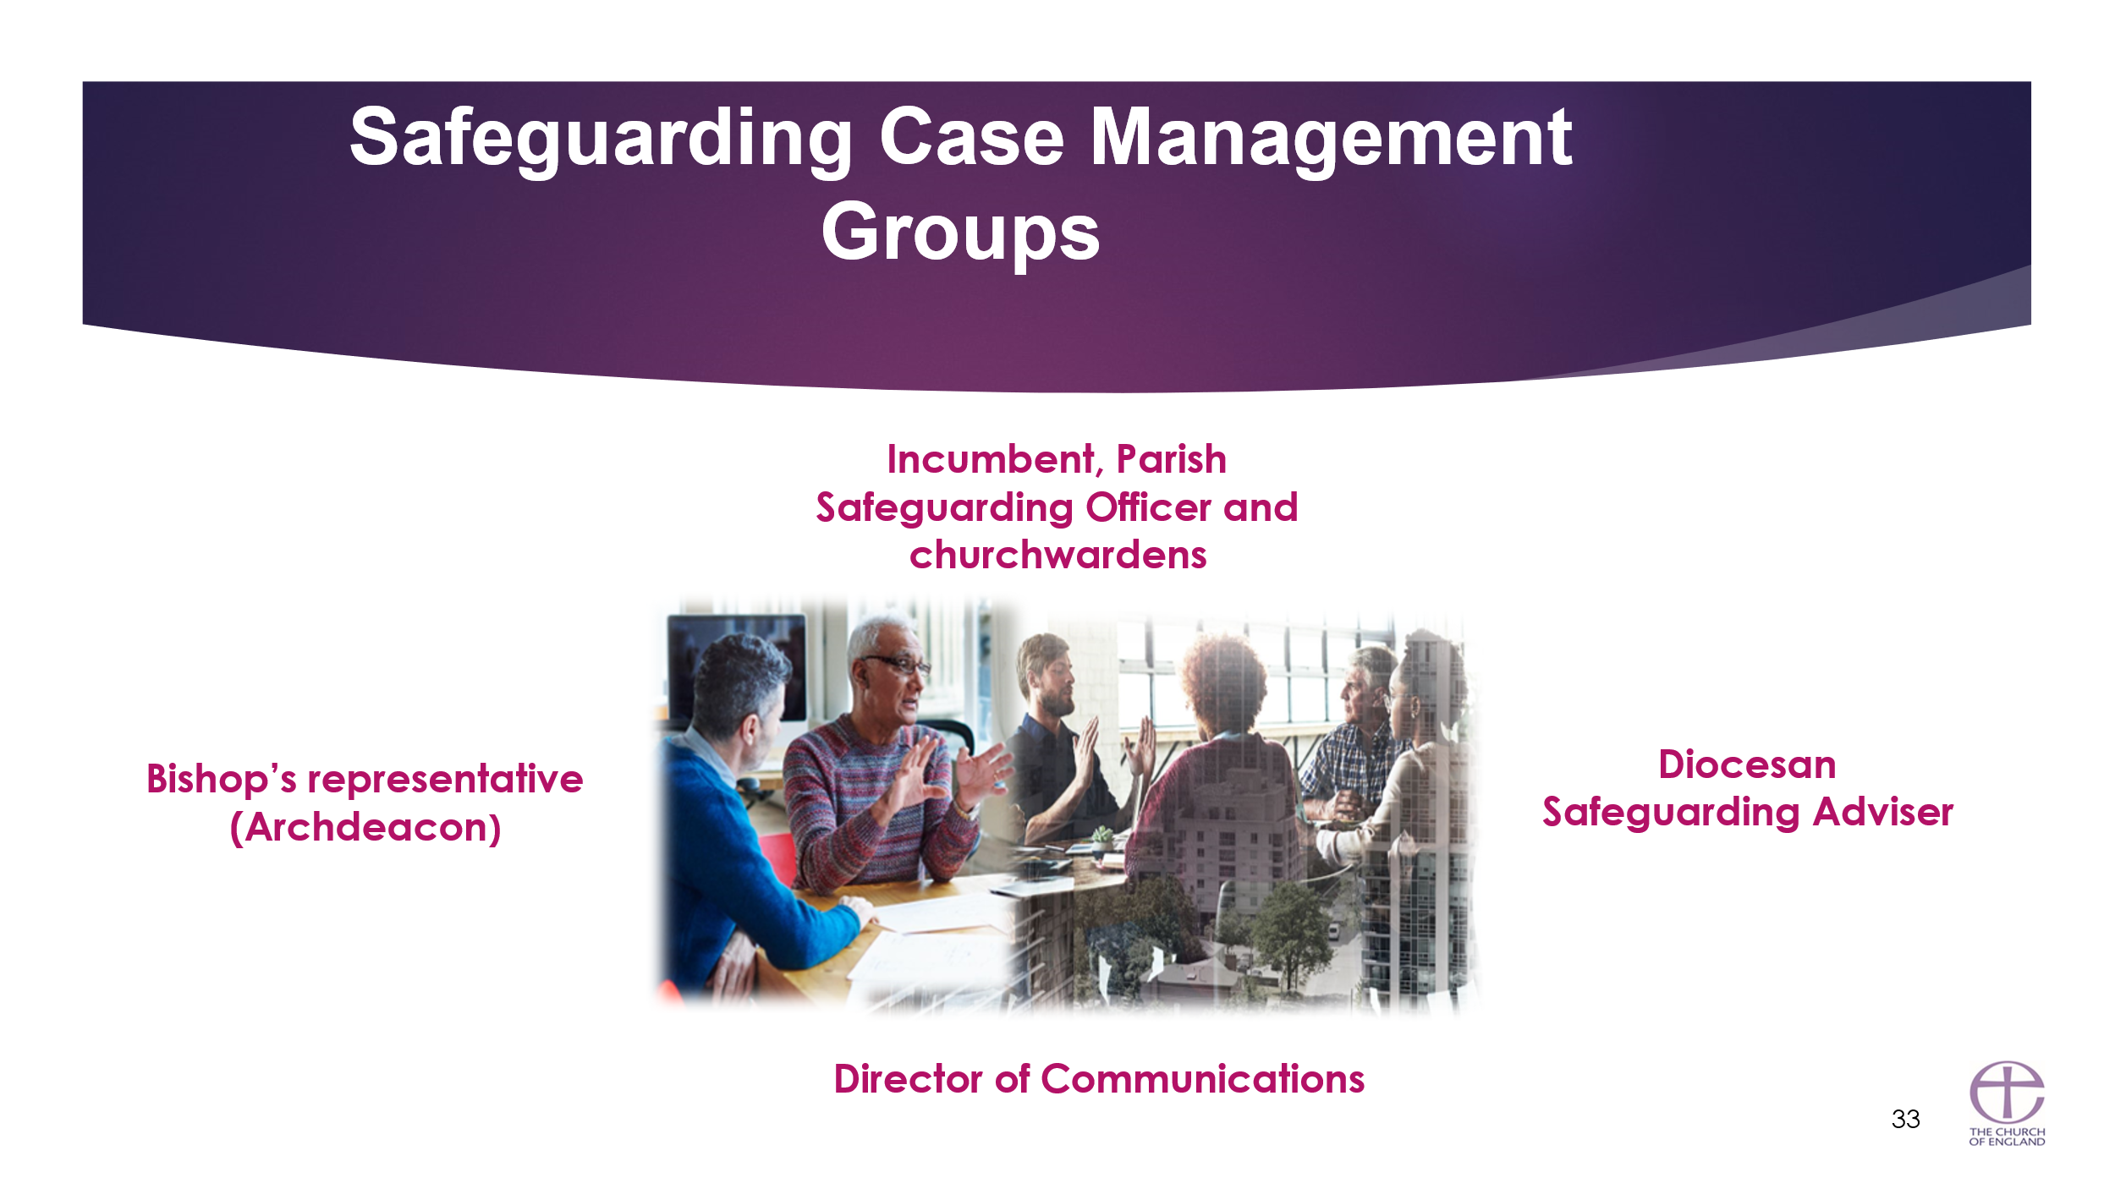
In every serious safeguarding situation which relates to a church officer, the case should be managed by a defined Safeguarding Case Management Group), convened for the specific situation. It’s convened normally within 48 hours of a concern being reported, its membership and tasks are laid out in the revised Safeguarding Code of Practice: Managing Allegations and Reporting Allegations (before Synod February 2025). Once approved, the Guidance can be located in the Safeguarding e-manual Safeguarding e-manual | The Church of England
- The safeguarding case management group works together from the very beginning of an allegation being made to the very end and will meet at various points throughout. The group is informed by statutory processes and Statutory meetings should be attended by the DSA and other diocesan/parish representatives.
- The purpose of the group is to ensure that practice guidance is followed, legal advice is sought as necessary, communications messages are managed and that the Bishop is advised on what should happen and decisions to be made – the group does not itself make decisions. The group is bound by confidentiality.
- In selecting the representation from the parish to attend it is important to apply common sense – the whole PCC does not need to know!
- The DSA is responsible for pulling the group together and will be the link between the group and the statutory agencies.
- The Bishops representative would usually be the archdeacon. It should not be the diocesan bishop as they may need to take disciplinary action in response to an allegation or concern and therefore need to remain out of the discussion process.

What to do when a concern is aised
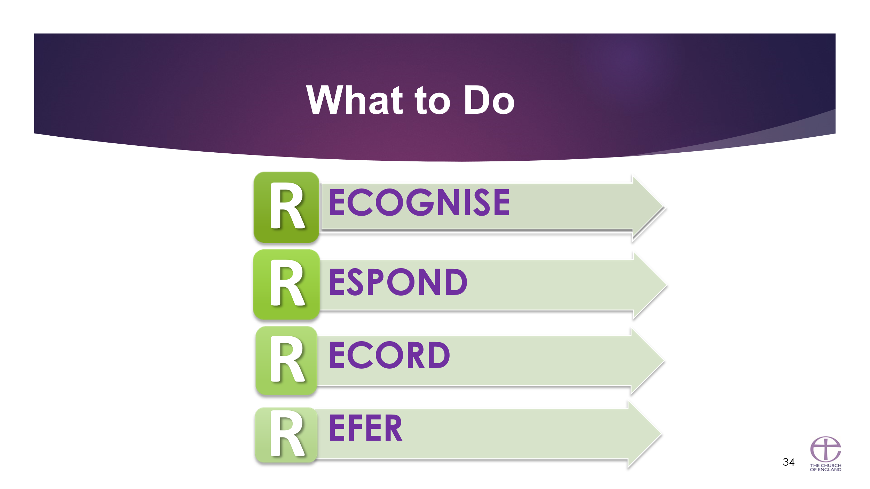
Key Messages
DO be calm
DO reassure
DO listen and observe carefully
DO record what has been said / communicated (date and sign it)
DO REFER WITHOUT DELAY
If you recognise something that causes you concern, don’t ignore it; respond.
The most important response will be to share/pass on your concerns to the DSA and involved them in the management of safeguarding issues in your parish – the DSA is your primary source of advice, support and guidance.

DO NOT show shock, distaste or disbelief
DO NOT introduce personal information or from either your own experience or that of others
DO NOT make comments about whom the allegation has been made.
DO NOT approach the person against whom the allegation has been made.
DO NOT ask leading questions or investigate.
DO NOT promise confidentiality - be clear you need to pass information on.
DO NOT tell the child, young person or vulnerable adult that “everything will be alright”.
DO NOT make promises that you cannot keep.
DO NOT try and manage / deal with everything yourself

Recording the Four Ws
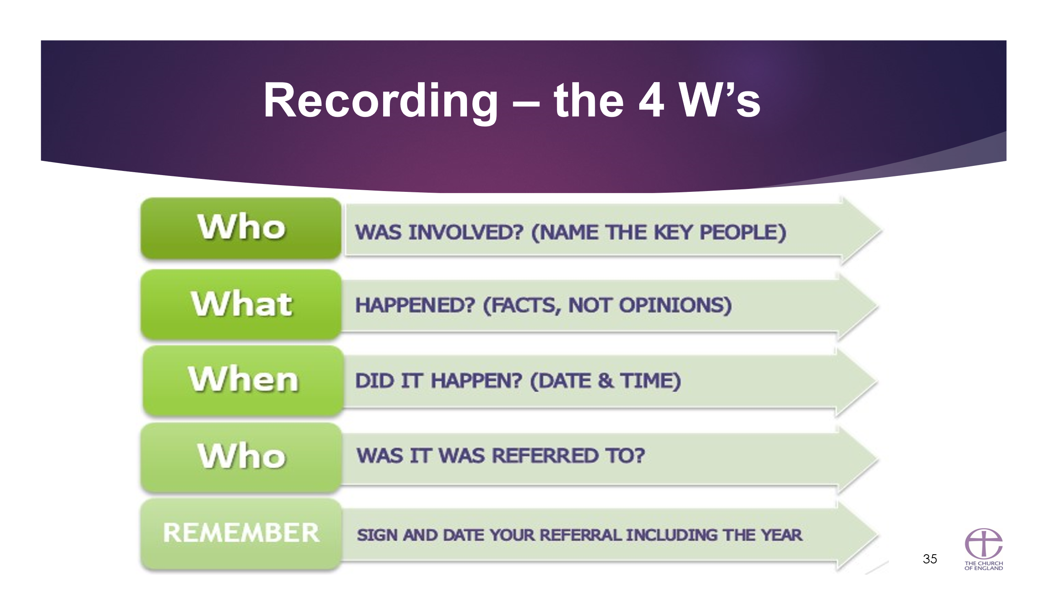

Key messages

Your Diocesan Safeguarding team will be able to provide a proforma for safeguarding incident concerns and recording:

- Reports should ideally be concise and to the point, not rambling essays.
- Take the name of the person to whom you have referred the matter.
- Please remember this is key information, and you are responsible for passing this information on to social services, the police or the DSA in writing.
- Only verbally pass the information on if an emergency situation but they must find time as soon as possible to write down, don’t delay a referral to speak to somebody else if someone is at immediate risk of harm, dial 999.
- Record exactly what you heard or observed. If possible do not add opinion but if you have to add an opinion make sure you describe it as such and why! Think about the communication issues disabled children have and how we can empower them to share their experience.
- Accuracy is paramount.
- The documents could be used in court and could therefore be your ‘original notes’ available for you to refer to many months later. Date, including the year. and signature on every document is very important.

Use of social media
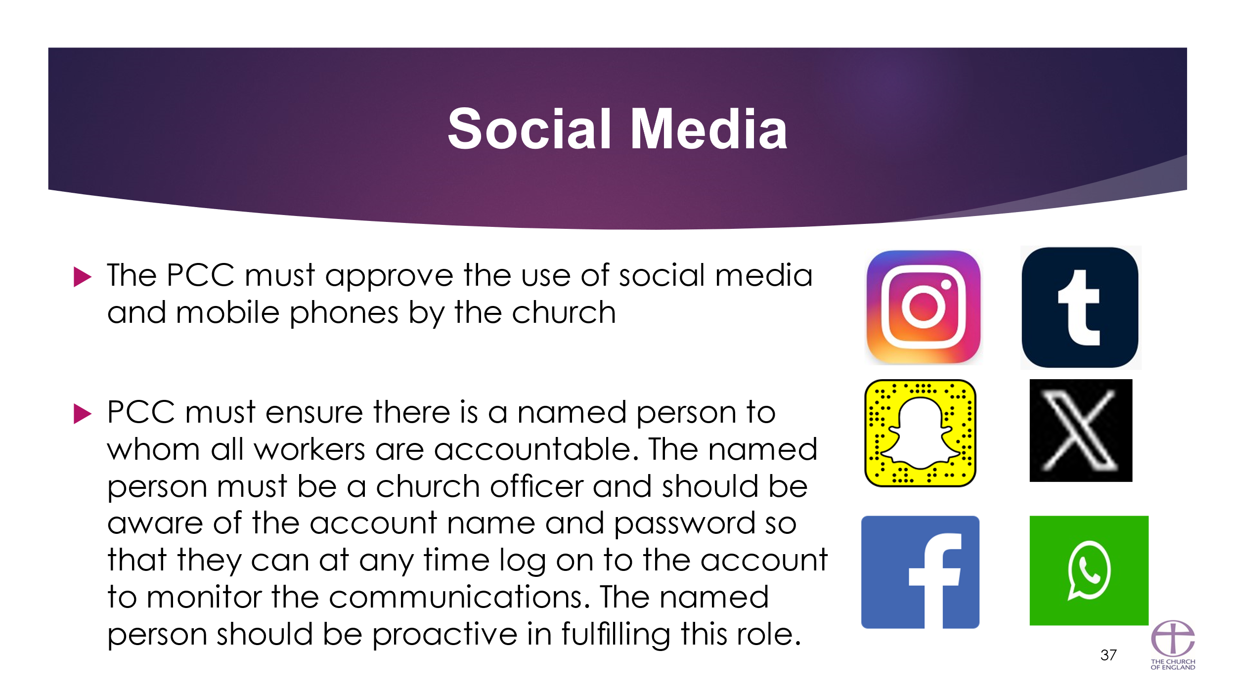
For many, especially young people, using social media is an extension of physical face-to-face relationships. It is therefore important that churches also engage with their community and worshippers through these platforms. However, this must be done safely to avoid the risk of enabling inappropriate behaviours, relationships, bullying or harassment
Guidance can be found under section 12 of the current Parish Safeguarding Handbook. See full document here: https://www.churchofengland.org/sites/default/files/2019-10/ParishSafeGuardingHandBookAugust2019Web.pdf

6. Parish Safeguarding Officer (PSO) Safeguarding Development Plan

Thank you for undertaking your PSO induction training. As a result of that we have asked you to complete a safeguarding development plan for yourself to help you in your role and your learning. This template is provided to help you undertake that task and we invite you to feel free to adapt it as best suits your needs.

Introduction
You come to this role with a range of personal, work and learning experiences . The purpose of this development plan is to help you identify where you would benefit from some support and learning to enable your life experiences to best serve you and your church in your role as a Parish Safeguarding Officer. The substance of this development plan is determined by you and then to be agreed with your Diocesan Safeguarding Team (DST). Start by identifying what are the strengths that you bring to this role, and then identify what support and training needs would help you make this role manageable and effective and help preserve your wellbeing.

Contact Details
Name: | Parish:
Phone: | Email:

The strengths I bring to this role are:

Development opportunities can take many forms and can be a mix of buddying up, mentoring, courses/self-directed learning, observation, reading shadowing etc. Allow yourself to think broadly but specifically about what would benefit you.
Support needs
 |  | To be agreed with your Diocesan Safeguarding Team
My support need | How will I know I have achieved it? | Priority/deadline | How, what and where can this be met?

Learning Needs
 |  | To be agreed with your Diocesan Safeguarding Team
My learning need | How will I know I have achieved it? | Priority/deadline | How, what and where can this be met?

Well done for identifying your strengths; support and learning needs. For these to benefit you, they now need to be discussed with your Diocesan Safeguarding Team. Your DST will be able to tell you about additional, resources, guidance documents and networking opportunities for PSOs. Once these have been agreed it will be for you and those identified within your plan to help you achieve it
This is not a binding contract but it is a commitment that you can make together, review as needed and follow through on what is agreed .

Signed: ___________________________________ ________________________________________ Date_____________________
(PSO) (DST) Review and revision period: _____________________

A ‘Church officer’ is anyone appointed/elected by or on behalf of the Church to a post or role, whether they are ordained or lay, paid or unpaid.
For the purpose of Church policy and guidance the definition of ‘vulnerable adult’ is contained in the Safeguarding and Clergy Discipline Measure 2016, which defines a ‘vulnerable adult’ as ‘a person aged 18 or over whose ability to protect himself or herself from violence, abuse, neglect or exploitation is significantly impaired through physical or mental disability or illness, old age, emotional fragility or distress, or otherwise; and for that purpose, the reference to being impaired is to being temporarily or indefinitely impaired’. Please note that the Care and Support Statutory Guidance issued under the Care Act 2014 (14.2) by the Department of Health uses the term ‘adults experiencing, or at risk of abuse or neglect’ to assess eligibility to statutory social care services.

