**USING GOOGLE TRANSLATE FOR ONLINE SAFEGUARDING TRAINING**

Whilst we can't provide our training directly in multiple languages, there is a tool in the Google Chrome browser that will translate the written material as you go. Google provides instructions for [Apple Devices](https://support.google.com/chrome/answer/173424?co=GENIE.Platform%3DiOS&oco=1), [Android Devices](https://support.google.com/chrome/answer/173424?co=GENIE.Platform%3DAndroid&oco=1), and [computers](https://support.google.com/chrome/answer/173424?co=GENIE.Platform%3DDesktop&oco=1).  
  
Our example below is based on using Chrome on a Windows 11 laptop.

Launch Chrome and click on the 'three dots' icon at the top right of the page and select "Settings" from the bottom of the menu.  
  
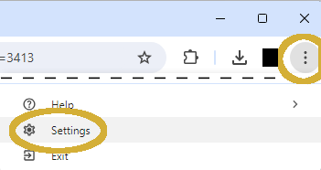  
  
Select "Languages" from the left hand menu and scroll down until you reach the Google Translate option. Turn it on and select the language you wish to use from the drop-down menu - our example uses Welsh.  
  
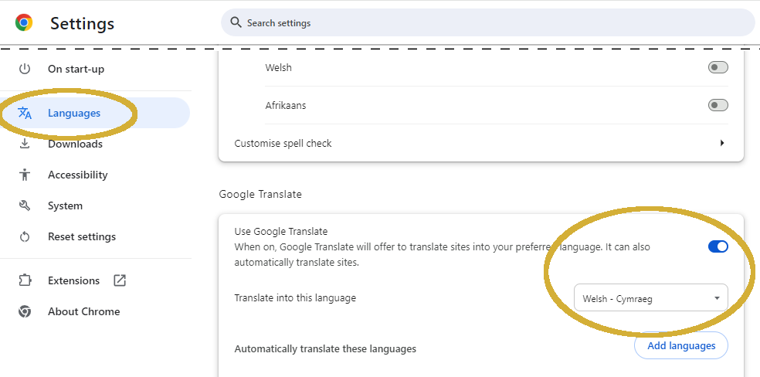  
  
Then navigate to the start of the course, let some of the text load and click on the Google Translate icon at the right hand side of the address bar (or select "Translate..." from the 'three dots' menu). It will open the Translate tool - click on your selected language and tick the "Always translate English" box (otherwise, you will need to re-select the new language for every page of the course).

  
  
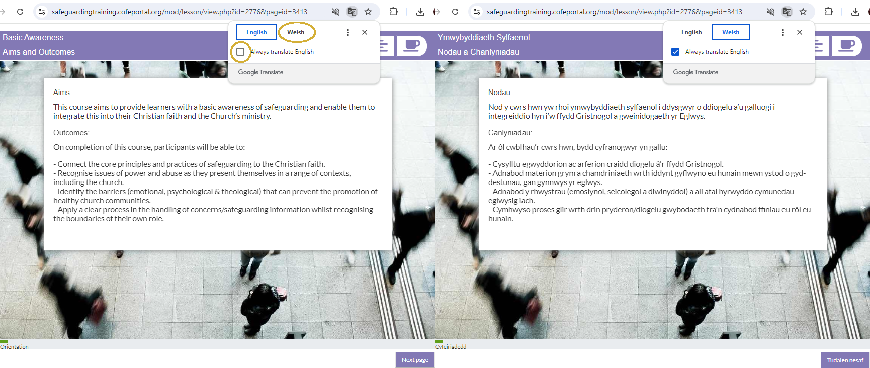  
  
You can switch back to English at any time by clicking on the icon again, unticking the check box and then clicking on "English".